**ASSIGNMENT 18.3**

**Problem Statement:**

Merge the small files in Hadoop by following the below blog

<https://acadgild.com/blog/merging-files-hdfs/>

**Input:**

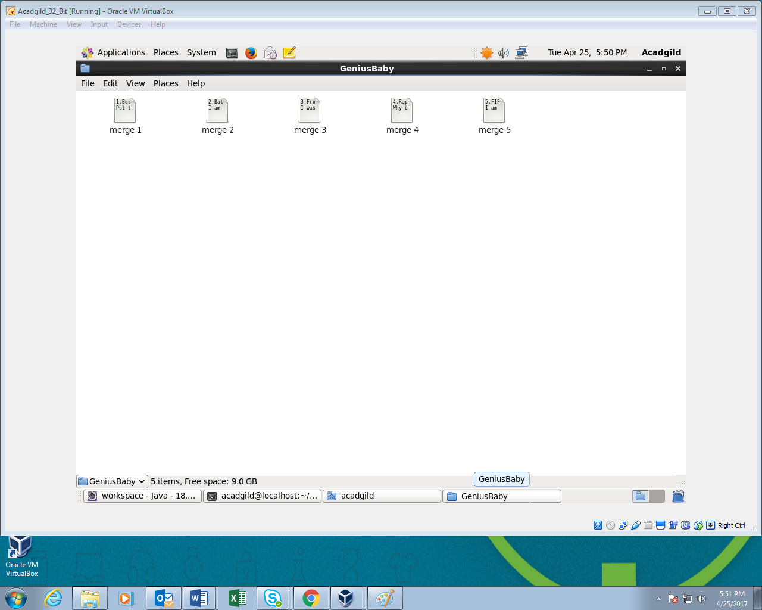

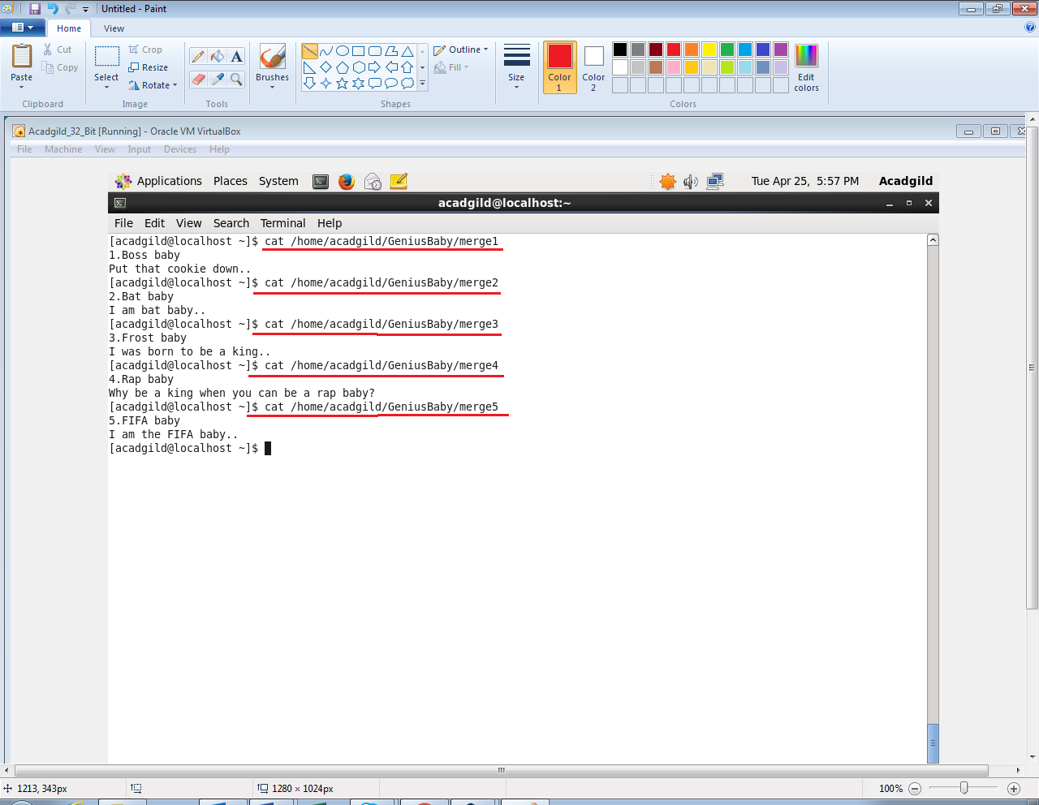

**Output:**

